The Emergency Card Information update for parents within myStudent is the information provided on the typical MIS 415 or MIS 416 form annual collected within the Orientation day process at school sites. Beginning this year, the Emergency Information can be provided electronically for each family. One entry will be made for each student enrolled.
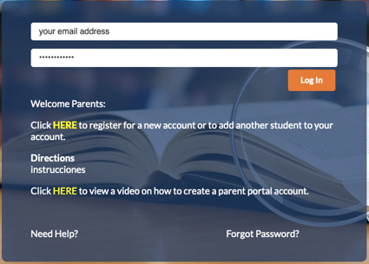 | A parent first will enter their portal account. They can access the parent portal from the District website on the Parent page and by selecting Check Grades/Attendance.  Select HERE to link to the myStudent Parent Portal.

After a parent logs in, they will first update their Legal Notices Acknowledgement prior to be brought to the portal entrance within myStudent. Each year, the Legal Notices are provided for parents through the parent portal entrance and the parent is asked to acknowledge. A parent will scroll to the bottom of the screen and acknowledge, by providing their first and last name in the signature line and selecting Acknowledge. After acknowledging the family can later access the Legal Notices in the News area of the Parent Portal for later review.
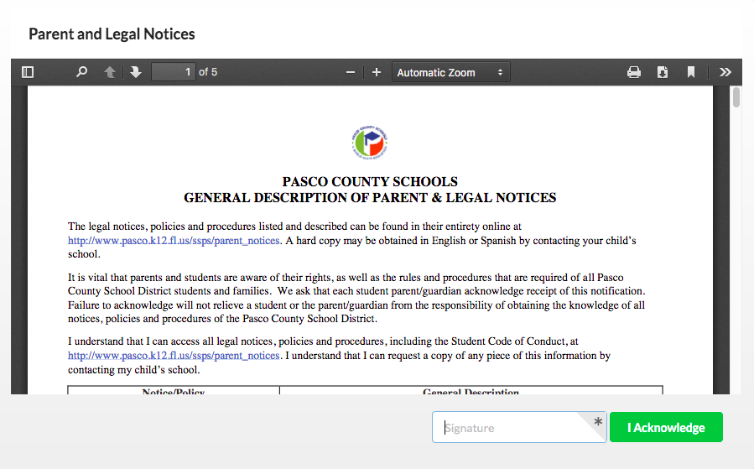

After the General Description of Parent and Legal Notices, the parent will be brought to the Emergency Information Card update screen. If a parent has multiple students enrolled in the school district, the parent will have a separate Emergency Information Card for update and review for each student. After completion of all Emergency Information Cards for each individual child, the parent will be able to move to the parent portal to pay fees and view the student schedule for each child. Bus pass information is available in the parent portal under the Transportation Routes page within the Child Info screen.
Note: Schedules will not be available until mid-August within the parent portal.
To begin an Emergency Information Card update, please select the Not yet started – Click here to begin button.
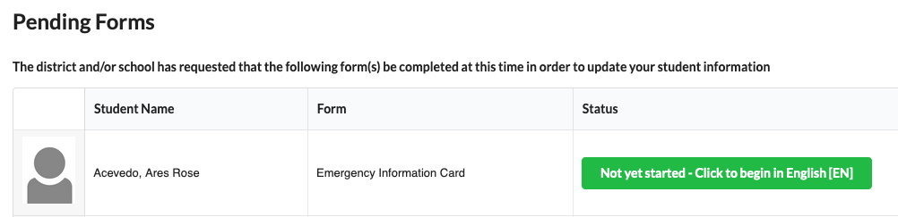

Page 1 of the Emergency Information Card: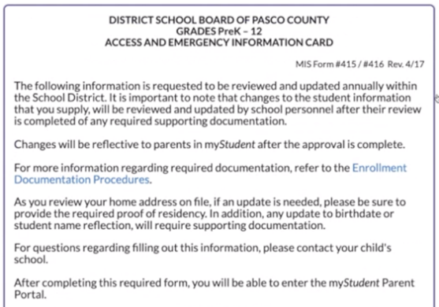 |  | Please review the Enrollment Documentation Procedures linked within page 1 of the Emergency Information Card for more information about Address update information and proof of residency requirements for an address update to be made in the student information system. After reviewing this page, select the Next Page button at the bottom of the screen.
Page 2 of the Emergency Information Card:  The next page a family will review is the Florida Statute language regarding updating residency information within a certain period of time. After reviewing the contents of this page, please select Next Page located at the bottom of the page. | 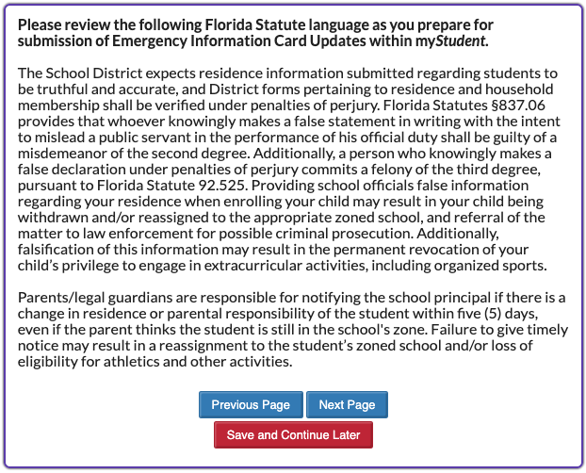
Page 3 of the Emergency Information Card:
This area will display the first, middle and last name of the student that is currently on file. In addition, the date of birth for the student that is on file will display. The parent will be asked to review this area and indicate No for no update needed or indicate Yes and provide a copy of the Birth Certificate for any update that is necessary. If Yes is selected, the the uploaded Birth Certificate is necessary to move forward within the Emergency Information Card update.
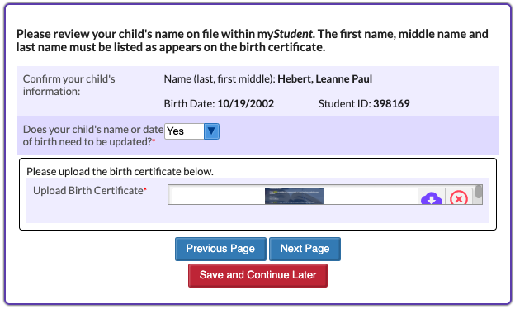

Page 4 of the Emergency Information Card:
This area will display the box to provide any brothers and/or sisters to the student’s Emergency Information Card that the parent is currently working to provide information for within myStudent. In order to save this area, please type within the text box area provided and select enter or return to initiate the SAVE button to appear. A parent can list multiple siblings by repeating the entry steps. A parent with one child may leave this box blank. It is important to note that the entry for this area is intended for students enrolled in a Pasco County School. Siblings not old enrolled, do not need to be provided.
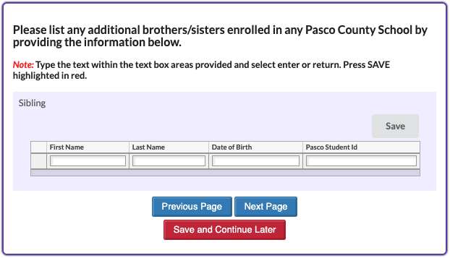
Note: As a parent is entering information, they will get a message below if they attempt to enter information without selecting the accompanying save button. To return to the Emergency Information Card area, the parent can select OK and then proceed to the save of the area.
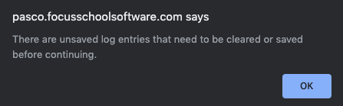

Page 5 of the Emergency Information Card:
This area will display the box to review the current primary address on file for the student. If after review, no update to the address is needed, please proceed to the Next Page.
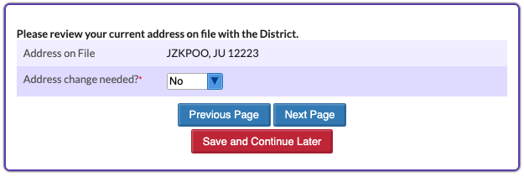
If after review, there is a need to update the primary address on file for the student, select Yes in the dropdown for Address change needed? Please remember, the accompanying three proofs of residency will be required. At any time, to get more information on the documentation necessary, select the Registration Requirements link within the Emergency Card Information page listed in the page.
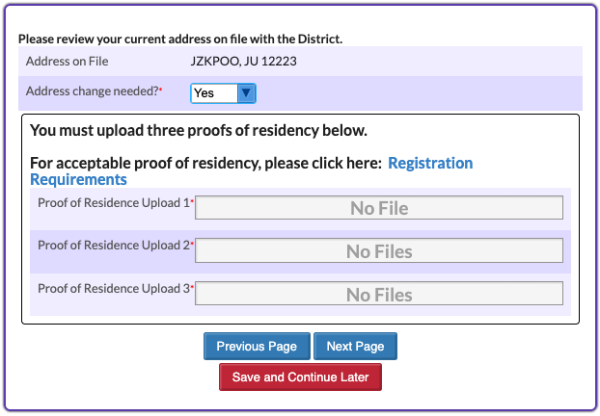

Page 6 of the Emergency Information Card:
The first area of this page will display the contact information currently on file for Custodial Contacts. In the below visual, the parent has reviewed the Custodial Contacts area and determined a need to update the information on file. By selecting Yes, the text area to enter specific information regarding contact information appears. Please remember to select enter or return on the computer keyboard in order to initiate the Save button becoming red. It will be necessary to select Save as it is highlighted in red.
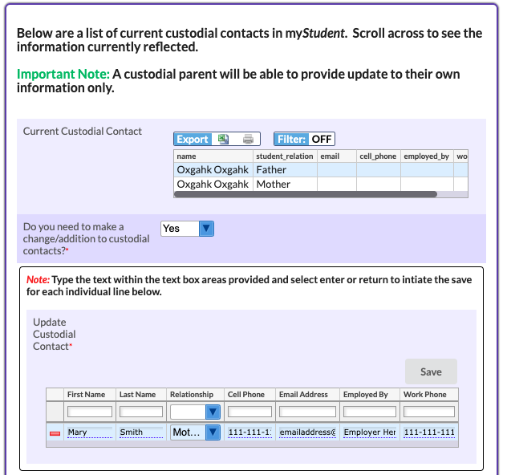

The next area on this page will display the contact information currently on file for Emergency Contacts. In the below visual, the parent will review the Emergency Contacts area and determined a need to update the information on file or not. By selecting Yes, the text area to enter specific information regarding contact information appears. The parent will have an area for update/changes and then an area for removing an Emergency Contact, who should no longer appear. Please remember to select enter or return on the computer keyboard in order to initiate the Save button becoming red if Yes is selected to update an Emergency Contact. It will be necessary to select Save as it is highlighted in red.
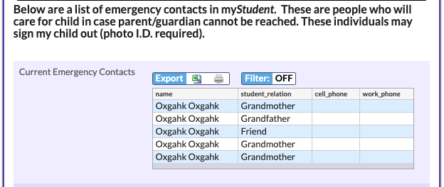
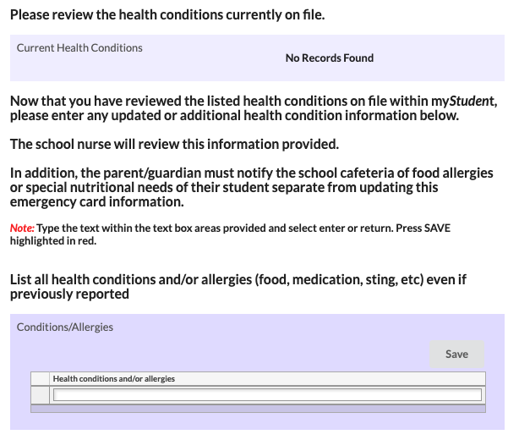
In the last section of this page, the parent has an area available to upload any supporting documentation regarding a person who may not legally contact their child.
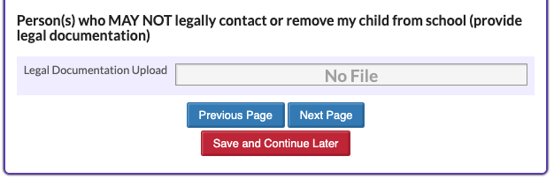
Page 7 of the Emergency Information Card:  The next page of the Emergency Card includes a focus on health related information for the parent to review and update. Please read carefully the information on the page regarding Parental Consent. | 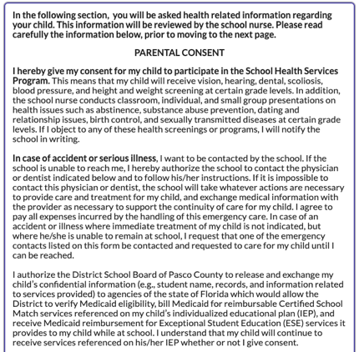
The next information on this page, is regarding health conditions currently listed within myStudent. The health conditions visible are from previous entries from information provided through paper MIS forms submitted annually. Please review the Health Conditions on file and please provide the current list of health conditions. This information will be reviewed by the School Nurse. Please note, this informatin will be reviewed in the order received and will be updated after full review is complete. The information will take time to be input in the parent portal for parents to see. In the below example, the parent will review Visual Impairment has been previously reported. After the parent review, they can add the visual impairment and any additional health conditions.
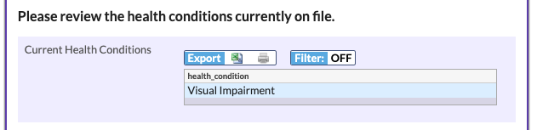
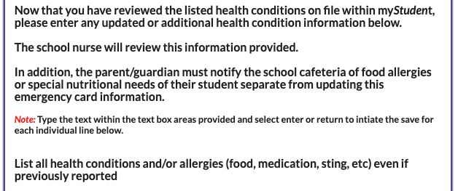
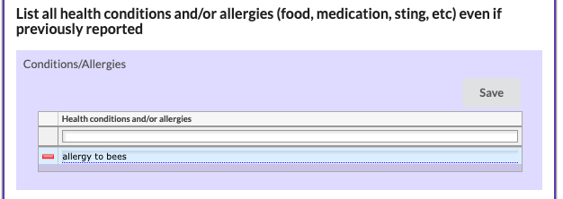
After review and providing any updates to the Health Conditions area, the parent will next list any medications. If there are no medications taken at home or at school, the parent can select the next area to continue.
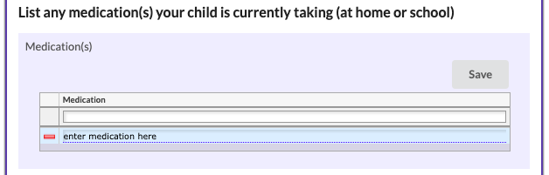

In the last area of this page, the parent is required to list physician, hospital and dentist name and phone numbers. These fields must be completed in order to move forward to the last steps toward submission of the Emergency Information Card. Multiple doctors can be listed as necessary. If at any point, a parent needs to leave the update area and return later they can select Save and Continue later. After entering this information and saving in each area, the parent can select next page.
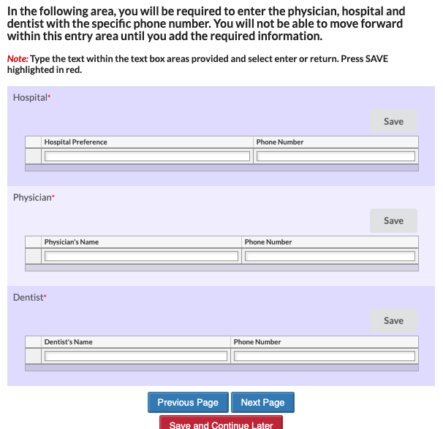

Page 8 of the Emergency Information Card:  This page reflects the Parental Consent Information and asks for the parent to indicate Consent by selecting Yes or No in the dropdown.  Note: If selecting No, the parent will need to contact their child’s school to obtain a paper copy of the Emergency Information Card and discuss their concerns for the Consent area. | 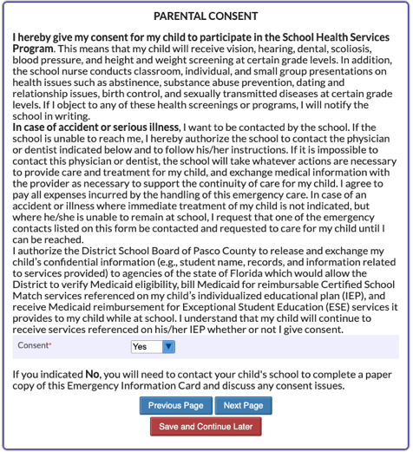
The final page of the Emergency Information Card, thanks you for your time in reviewing and completing the form submission. In order to finish, select Submit and Finish. If at any time, a parent needs to revisit a previous page, they may do so prior to submission. Any updates after submission, will require contacting your child’s school and working with them to update the information on file.
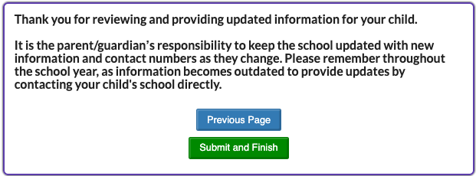
A parent can return to the parent portal to continue reviewing and submitting Emergency Information Cards for additional students. After completion of the last form, the parent can view student information through the parent portal.
For assistance regarding submission of the Emergency Information Card, please reach out to myStudenthelp@pasco.k12.fl.us

